Supplementary Materials

Table 1S. Specification of MB and BF dyes and their λ_{max} by UV-VIS detection.

Dye | Chemical formula | Molecular weight | Color index | λ_{max}
Methylene blue  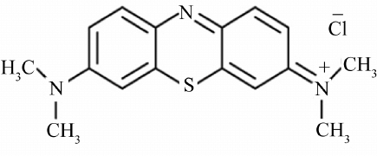 | C₁₆H₁₈ClN₃S | 319.85 g/mol | 52015 | 665 nm
Basic fuchsin  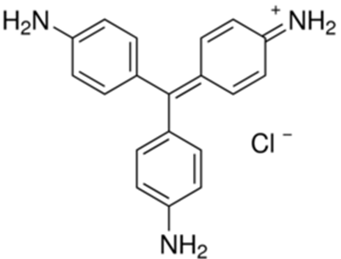 | C₂₀H₂₀N₃·HCl | 337.86 g/mol | 42500 | 545 nm

Table 2S. Various investigated kinetic isotherm models for removal of MB and BF by BCCW-NB nanobiosorbent

Kinetic model | Linear form | Parameter definition | Plot
Pseudo-first order | ln (q_{e} – q_{t} ) = ln q_{e} – k₁t | q_{e} and q_{t} are the adsorbed amount of MB and BF dyes (mg g⁻¹) at equilibrium and at time t (min), respectively, k1 is pseudo-first order rate constant (min⁻¹). | ln(q_{e}−q_{t}) vs. the time (t)
Pseudo-second order | t ⁄ q_{t} = 1 ⁄ k₂q_{e}² + t ⁄ q_{e} | q_{e} and q_{t} are the adsorbed amount of MB and BF dyes (mg g⁻¹) at equilibrium and at time t (min), respectively, k₂ stands for the second order rate constant of adsorption (g/(mg min) | t/q_{t} vs. time (t),
The intra-particle diffusion | q_{t} = k_{id} t ^{½} + C | k_{id} is the intraparticle diffusion rate constant (mg g⁻¹ min^{−1/2} ). C is the thickness of the boundary laye (mg g⁻¹) | (q_{t}) vs. (t^{1/2})
The Elovich |  | α is for the initial rate of adsorption (mg g⁻¹ min) and β is the activation energy of chemisorption and surface coverage | q_{t} vs. ln t
The Boyd | B _{t} = - 0.4977 – ln (1 – F)  F = q _{t} / q _{e} | q_{e} and q_{t} is mass of MB and BF dyes adsorbed at quilibrium and at time t (mg/g), F for the fraction of solute adsorbed at time t, and B_{t} is the mathematical function of F | B_{t} were plotted vs. time t

Table 3S. Various investigated isotherm models using in adsorption of MB and BF by BCCW-NB nanobiosorbent

Adsorption model | Linear form | Parameter definition | Plot
Langmuir | $$\frac{C_{e}}{q_{e}}=\frac{C_{e}}{q_{m}}+\frac{1}{q_{m}b}$$  Separation factor:  R_{L} = 1 ⁄ 1+bCₒ  Unfavorable if (R_{L}>1), favorable (0< R_{L}<1), linear (R_{L} = 1) or irreversible (R_{L}=0) | C_{o} and C_{e} is for to the initial and equilibrium concentrations (mg L⁻¹), respectively. q_{e} is the adsorbed dye quantity (mg g⁻¹) at equilibrium. q_{max} (mg g⁻¹) and b (L mg⁻¹) are the maximum capacity of adsorption and Langmuir constants | C_{e}/q_{e} vs. C_{e}
Freundlich |  | q_{e} is the amount of adsorbed solute and C_{e} is for the equilibrium solute concentration. K_{F} (mg g⁻¹) is Freundlich constant, n is the intensity of the adsorbents. | log q_{e} vs. log C_{e}
Temkin | q_{e} = (RT ⁄ b_{T} ) ln a_{T} + (RT ⁄b_{T}) ln c_{e}  q_{e} = B ln a_{t} + B ln C_{e}  B = $\frac{RT}{bt}$ | b_{T} (mg L⁻¹) is the Temkin isotherm constant, a_{T} (L g⁻¹) is the Temkin isotherm equilibrium binding constant and B is for a constant which expresses the adsorption heat (J/mol) | q_{e} vs. ln C_{e}
Dubinin–Radushkevich (D–R) | ln q_{e} = ln q_{s} – ( K_{ad} Ɛ² )  Ԑ =RT ln (1 + 1⁄Ce) | q_{s} (mg g⁻¹) is for the saturation capacity, K_{ad} denotes the D–R isotherm constant that is for the mean adsorption free energy per mole of adsorbate (mol²/kJ²). Ԑ is for the Polanyi potential, R is the universal gas constant (8.314 J/mol K⁻¹) and T absolute temp. Kelvin | ln q_{e} versus ε²
Scatchard | (q_{e} / C_{e} ) = Q ⃘b – q_{e} b | q_{e} and C_{e} are the equilibrium adsorption capacity of the adsorbent and equilibrium concentration respectively, Qº and b are adsorption isotherm parameters | ( q_{e} / C_{e} ) verses q_{e}

