**Molecular dynamics simulations of *s*-triazine-based MMP-10 inhibitor with ferroptosis induction capacity and potent anti-colorectal cancer activities**

Omar A.Soliman 1, 2 , Christine A. Morcos 3, * , Nesreen S. Haiba 4 , Rafik W. Bassily  3 , Marwa M. Abu-Serie  5 , Mohamed Teleb  6 , Sherine N. Khattab 3

*1 Department of Clinical Pharmacy, Alexandria University Main Teaching Hospital, Alexandria, Egypt.*

*2 Department of Human Genetics, Medical Research Institute, Alexandria University, Alexandria, Egypt.*

*3* *Chemistry Department, Faculty of Science, Alexandria University, Alexandria 21321, Egypt.*

*4 Department of Physics and Chemistry, Faculty of Education, Alexandria University, Egypt.*

*5 Medical Biotechnology Department, Genetic Engineering and Biotechnology Research Institute, City of Scientific Research and Technological Applications (SRTA-City), Egypt.*

*6 Department of Pharmaceutical Chemistry, Faculty of Pharmacy, Alexandria University, Alexandria 21521,* *Egypt.*

**Table of content**

|  |  |  |  |  |
| --- | --- | --- | --- | --- |
|  | **Content** | | **Page No.** | |
| **S1** 1H-NMR (DMSO-*d6*) spectrum of **I**  **S2** 1H-NMR (DMSO-*d6* D2O) spectrum of **I**  **S3** 13C-NMR (DMSO-*d6*) spectrum of **I** | | **2**  **3**  **4** | |

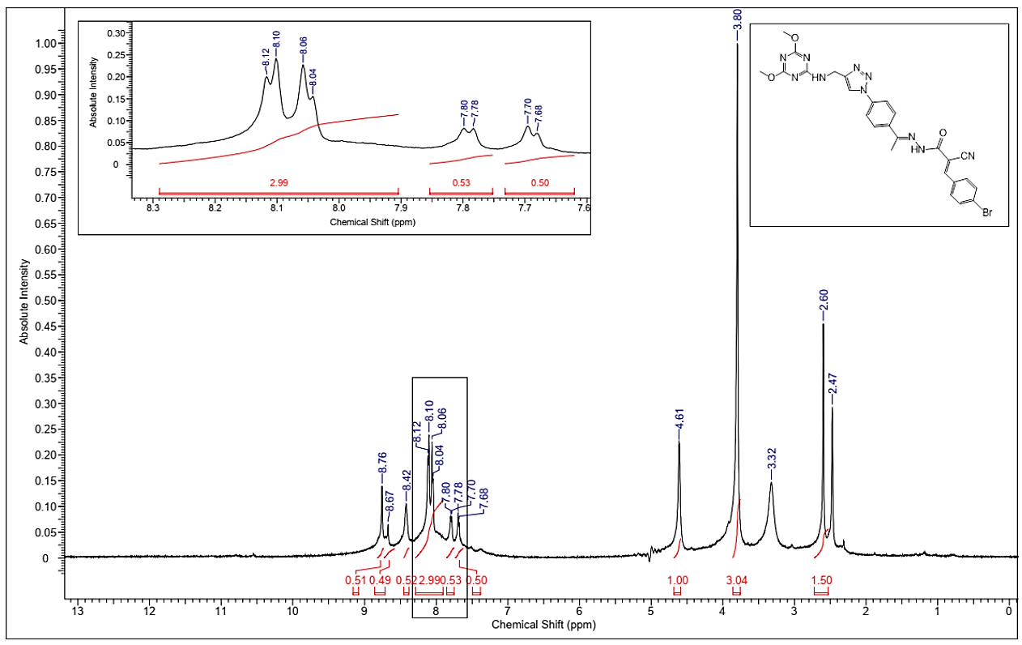

**Figure S1:** 1H-NMR (DMSO-*d6*) spectrum of *(E)*-3-(4-bromophenyl)-2-cyano-*N'*-((*E*)-1-(4-(4-(((4,6-dimethoxy-1,3,5-triazin-2-yl)amino)methyl)-1*H*-1,2,3-triazol-1-yl)phenyl)ethylidene)acrylohydrazide(**I**).

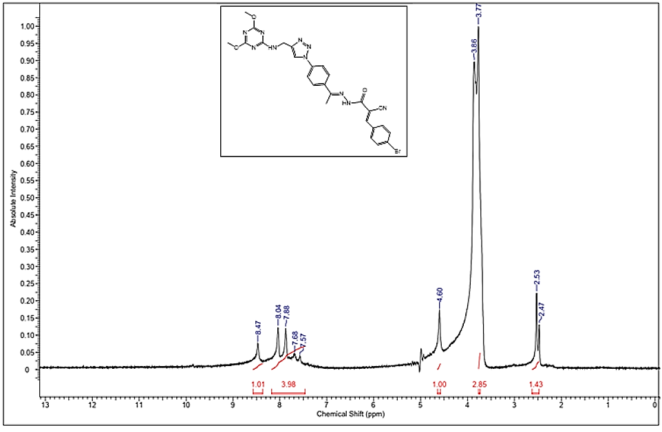

**Figure S2:** 1H-NMR (DMSO-*d6* D2O) spectrum of *(E)*-3-(4-bromophenyl)-2-cyano-*N'*-((*E*)-1-(4-(4-(((4,6-dimethoxy-1,3,5-triazin-2-yl)amino)methyl)-1*H*-1,2,3-triazol-1-yl)phenyl)ethylidene)acrylohydrazide(**I**).

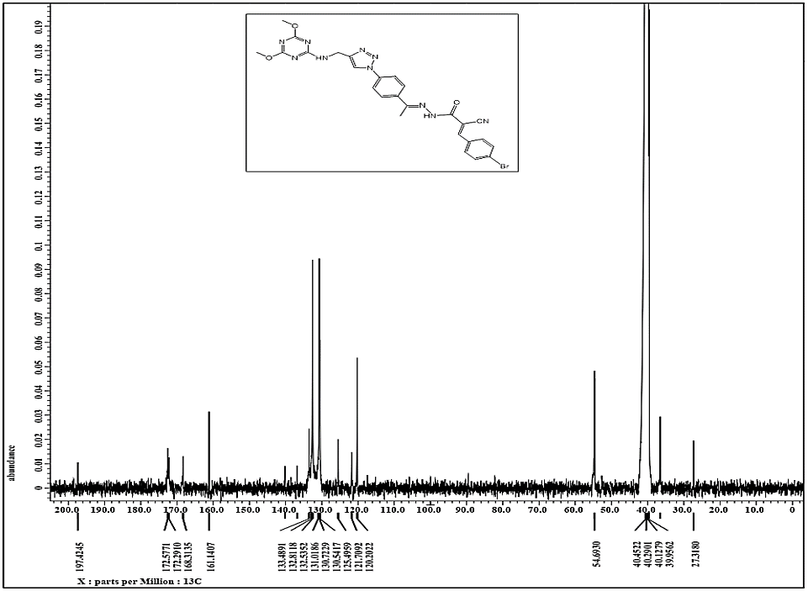

**Figure S3:** 13C-NMR (DMSO-*d6*) spectrum of *(E)*-3-(4-bromophenyl)-2-cyano-*N'*-((*E*)-1-(4-(4-(((4,6-dimethoxy-1,3,5-triazin-2-yl)amino)methyl)-1*H*-1,2,3-triazol-1-yl)phenyl)ethylidene)acrylohydrazide(**I**).



**Scheme S1.** Synthetic route for (*E*)-3-(4-bromophenyl)-2-cyano-*N*'-((*E*)-1-(4-(4-(((4,6-dimethoxy-1,3,5-triazin-2-yl)amino)methyl)-1*H*-1,2,3-triazol-1-yl)phenyl)ethylidene)acrylohydrazide (**I**).

***Docking***

The coordinates of MMP-10 active domain were retrieved from the Protein Data Bank (PDB ID: 1Q3A [1]) and handled with MOE 2019.102 [2]. Unwanted crystallographic artifacts and repeated chains were eliminated then the catalytic domain was prepared and refined employing the default “Structure preparation” MOE setting, and then energy was minimized employing Amber10: EHT force field with reaction-field electrostatics (an interior dielectric constant of 1 and an exterior dielectric of 80) using an 8–10 Å cutoff distance. The site for docking was located as the co-crystallized ligand atoms binding site. The studied MMP-10 inhibitor was built *in silico*, energy minimized *via* MMFF94x force field at 0.01 RMSD gradient, then docked employing a validated rigid docking protocol (used for redocking NNGH) *via* triangular matcher algorithm as the ligand placement method [3,4] and London dG as the default scoring function [5] for generating the top non-redundant ten poses which were rescored employing the GBVI/WSA dG scoring function [6]. The top docking pose was selected based on the lowest recorded free binding energy and then subjected to molecular dynamics simulations.

***Molecular dynamics simulations***

The PDB file was cleaned to remove all non-protein atoms, such as crystal waters and unnecessary ligands. The input files for MD calculations were generated by the CHARMM-GUI solution builder [7–9]using CHARMM force field parameters. The topologies of the selected ligand were generated using CHARMM General Force Field through the *CgenFF* server [10]. The CHARMM-GUI solution builder included five steps. In the first step, the coordinates of the protein-ligand complex are read by the tool. The second step involved the solvation of the protein-ligand complex as well as determining the shape and size of the system. Na+ and Cl- ions were added in this step to neutralize the system. Periodic Boundary Conditions (PBC) were set in the third step which were used for approximation of a large system by using a unit cell which was then replicated in all directions. The simulation took place only for the atoms that were present inside the PBC box. Complexes had 64 Å, 64 Å, and 64 Å dimensions for the PBC box in x, y, and z, respectively. Bad contacts were removed in this step by running short minimization. The fourth and fifth steps involved equilibration of the system and production. Equilibration was done in two phases; NVT ensemble and NPT ensemble to ensure that the system had achieved the desired temperature and pressure. The input files for equilibration and production were then downloaded and desired changes were made including several steps of MD run, frequency of saving of trajectories, and calculation of energy. Non-bonded interactions were treated with a 12 Å cutoff distance and the neighbor searching list was buffered with the Verlet cutoff-scheme. The long-range electrostatic interactions were treated with the particle mesh Ewald (PME) method. Before production simulation, energy minimization of the system was carried out by using the steepest descent algorithm (5000 steps). The complex was then equilibrated to stabilize its temperature and pressure by subjecting it to NVT and NPT ensemble and simulating for 125 ps at 300.15 K temperature using 400 kJ mol−1 nm−2 and 40 kJ mol−1 nm−2 positional restraints on the backbone and side chains, respectively. Finally, the complex was subjected to a production simulation run for 50 ns in NPT ensemble at 300.15 K and 1 bar. Energy conservation was tracked by monitoring the total energy of the system, which includes potential energy, kinetic energy, and any contributions from constraints or external factors. Visualization tools like VMD and PyMOL were used to inspect the system for any overlapping atoms or unusual configurations. This helped ensure there were no atoms occupying the same space, which can lead to non-finite forces. Accurate calculations were ensured by switching to double precision in GROMACS. This helped to minimize numerical errors that could otherwise lead to issues with energy conservation. The initial coordinates were manually adjusted to resolve any overlaps found. This was essential for preventing significant energy errors during the simulation. For bonds involving hydrogen atoms, we employed the LINCS algorithm (constraints = h-bonds in the minimisation.mdp file) to maintain the bond lengths accurately, helping to prevent significant energy errors. Temperature was controlled using the Nosé-Hoover thermostat (tcoupl = nose-hoover) with a coupling constant (tau_t) of 0.1 ps. Pressure was controlled using the Parrinello-Rahman barostat (pcoupl = parrinello-rahman) with a coupling constant (tau_p) of 2.0 ps. These settings were chosen to balance effective temperature and pressure control with minimal disturbance to energy conservation. The V-rescale thermostat at 300 K with a coupling constant of 1 ps was used. The trajectories were stored every 2 ps. Simulations of 50 ns in NPT assembly were performed for the production stage [11]. GROMACS [12]was employed for running simulations. RMSD was calculated by the *gmx_rms* subprogram. RMSF by *gmx_rmsf*. rGyr by *gmx_gyrate*, number of hydrogen bonds (inside the protein-ligand interface) by *gmx_hbond,* and COM by *gmx_distance* during the simulation. The VMD molecular graphics program was used for trajectory visualization and contact frequency (CF) analysis [11]. The Prolif tool [13] was employed using all parameters by default to evaluate all possible target-ligand interactions over the whole simulation time. MM/PBSA calculations were done using *g_mmpbsa*, a GROMACS tool. The binding free energy of the complexes in a solvent can be expressed as:, where  is the total free energy of the complex, and  and  are the total free energies of the isolated protein and ligand in the solvent, respectively. *g_mmpbsa* was also used to estimate the energy contribution per residue to the binding energy. Considering that *g_mmpbsa* only read the files of some specific GROMACS versions, the binary run input file (.tpr) required for MM-PBSA calculation through the *g_mmpbsa* was regenerated by GROMACS 5.1.4. The molecular structure file (.gro), topology file (.top), and MD-parameter file (.mdp) were necessary to generate the binary run input file, and they all came from the MD process [14].

**References**

[1] Bertini, I.; Calderone, V.; Fragai, M.; Luchinat, C.; Mangani, S.; Terni, B. Crystal Structure of the Catalytic Domain of Human Matrix Metalloproteinase 10. J. Mol. Biol. 2004, 336(3), 707–716.

[2] Molecular Operating Environment (MOE) 2019.0102. Chemical Computing Group Inc.: Montreal, QC, Canada.

[3] Pasha M. K.; Munawar, K.; Talib Qureshi, A. Application of the Docking Protocol Optimization for Inhibitors of IGF-1R and IR and Understanding Them through Artificial Intelligence and Bibliography. International Journal of Education and Management Engineering. 2021, 11(4), 1–11.

[4] Galli, C. L.; Sensi, C.; Fumagalli, A.; Parravicini, C.; Marinovich, M.; Eberini, I. A. Computational Approach to Evaluate the Androgenic Affinity of Iprodione, Procymidone, Vinclozolin and Their Metabolites. PLoS One. 2014, 9(8), e104822.

[5] Corbeil, C. R.; Williams, C. I.; Labute, P. Variability in Docking Success Rates Due to Dataset Preparation. J. Comput. Aided Mol. Des. 2012, 26(6), 775–786.

[6] Su, M.; Yang, Q.; Du, Y.; Feng, G.; Liu, Z.; Li, Y.; Wang, R. Comparative Assessment of Scoring Functions: The CASF-2016 Update. J. Chem. Inf. Model. 2019, 59(2), 895–913.

[7] Jo, S.; Kim, T.; Iyer, V. G.; Im, W. CHARMM‐GUI: A Web‐based Graphical User Interface for CHARMM. J. Comput. Chem. 2008, 29(11), 1859–1865.

[8] Brooks, B. R.; Brooks, C. L.; Mackerell, A. D.; Nilsson, L.; Petrella, R. J.; Roux, B.; Won, Y.; Archontis, G.; Bartels, C.; Boresch, S.; Caflisch, A.; Caves, L.; Cui, Q.; Dinner, A. R.; Feig, M.; Fischer, S.; Gao, J.; Hodoscek, M.; Im, W.; Kuczera, K.; Lazaridis, T.; Ma, J.; Ovchinnikov, V.; Paci, E.; Pastor, R. W.; Post, C. B.; Pu, J. Z.; Schaefer, M.; Tidor, B.; Venable, R. M.; Woodcock, H. L.; Wu, X.; Yang, W.; York, D. M.; Karplus, M. CHARMM: The Biomolecular Simulation Program. J. Comput. Chem. 2009, 30(10), 1545–1614.

[9] Lee, J.; Cheng, X.; Swails, J. M.; Yeom, M. S.; Eastman, P. K.; Lemkul, J. A.; Wei, S.; Buckner, J.; Jeong, J. C.; Qi, Y.; Jo, S.; Pande, V. S.; Case, D. A.; Brooks, C. L.; MacKerell, A. D.; Klauda, J. B.; Im, W. CHARMM-GUI Input Generator for NAMD, GROMACS, AMBER, OpenMM, and CHARMM/OpenMM Simulations Using the CHARMM36 Additive Force Field. J. Chem. Theory Comput. 2016, 12(1), 405–413.

[10] Vanommeslaeghe, K.; Hatcher, E.; Acharya, C.; Kundu, S.; Zhong, S.; Shim, J.; Darian, E.; Guvench, O.; Lopes, P.; Vorobyov, I.; Mackerell, A. D. CHARMM General Force Field: A Force Field for Drug‐like Molecules Compatible with the CHARMM All‐atom Additive Biological Force Fields. J. Comput. Chem. 2010, 31(4), 671–690.

[11] Jose, S.; Gupta, M.; Sharma, U.; Quintero-Saumeth, J.; Dwivedi, M. Potential of Phytocompounds from Brassica Oleracea Targeting S2-Domain of SARS-CoV-2 Spike Glycoproteins: Structural and Molecular Insights. J. Mol. Struct. 2022, 1254, 132369.

[12] GROMACS: fast, flexible, free. http://www.gromacs.org/. Accessed 25 August 2023.

[13] Bouysset, C.; Fiorucci, S. ProLIF: A Library to Encode Molecular Interactions as Fingerprints. J. Cheminform. 2021, 13(1), 72, 1–9.

[14] Mostafa, H. M. A.; Taha, M.; El-Gendy, A. O.; Khairalla, A. S.; abd El fattah, M.; Raslan, M. Antimicrobial and Antivirulence Saponins of Mimusops Laurifolia Leaves. Lett. Appl. Microbiol. 2023, 76(7), ovad071.