**Supporting Information**



Fig.SI.1: Mass spectra of GCC1 crystal.

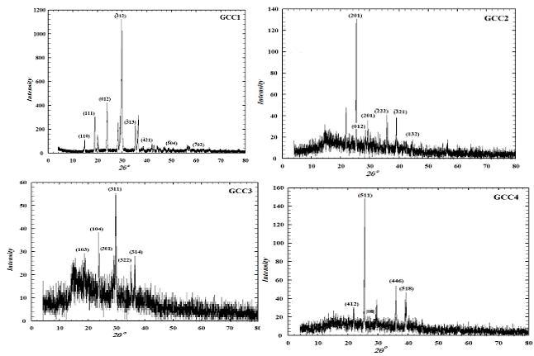

Fig. SI.2: Powder XRD pattern of glycine GCC crystals.



Fig.SI.3a: FTIR spectrum of GCC1 single crystal



Fig. SI.3b: FTIR spectrum of GCC2 single crystal



Fig.SI.3c:FTIR spectra of GCC3 single crystal



Fig.SI.3d:FTIR spectra of GCC4 single crystal

Fig.SI.4:Powder EPR spectrum of GCC1 at room temperature.

Table SI.1:Elemental analysis of the elements: C , H , N in GCC1 single crystal

|  |  |  |  |  |  |  |  |  |  |  |  |  |
| --- | --- | --- | --- | --- | --- | --- | --- | --- | --- | --- | --- | --- |
| C % | N % | H % | O % | n Carbon | n nitrogen | n Hydrogen | n metal105 | n Oxygen | C | N | H | O |
| 60.66 | 23.58 | 6.8 | 9.0 | 5.05 | 1.68 | 6.74 | 7.0 | 0.56 | 9.0 | 3.0 | 12 | 13 |

Table SI.2:The Indexed powder X-ray diffraction pattern for (GCC) single crystals.

|  |  |  |  |  |  |  |
| --- | --- | --- | --- | --- | --- | --- |
| intensity % | (hk) | d(A) (calc) | d(A)Exp | 2θ(Calc) | 2θ(Exp) | GCC1 |
| 8.4 | (110) | 6.19657 | 5.98755 | 14.282 | 14.783 |
| 25.9 | (111) | 4.56464 | 4.68284 | 19.431 | 18.936 |
| 35.6 | (012) | 3.74848 | 3.7238 | 23.717 | 23.877 |
| 100 | (12) | 2.98886 | 2.99398 | 29.870 | 29.818 |
| 19.3 | (13) | 2.52942 | 2.53584 | 35.460 | 35.368 |
| 2.4 | (21) | 2.20858 | 2.20621 | 40.825 | 40.871 |
| 1.8 | (02) | 1.52557 | 1.52779 | 60.653 | 60.556 |
| 100 | (210) | 3.50587 | 3.51649 | 25.385 | 25.307 | GCC2 |
| 15.7 | (012) | 3.13919 | 3.13724 | 28.409 | 28.427 |
| 15.9 | (201) | 2.97138 | 2.96751 | 30.05 | 30.09 |
| 29.8 | (22) | 2.47483 | 2.49982 | 36.270 | 35.895 |
| 29.3 | (21) | 2.27182 | 2.30464 | 39.640 | 39.053 |
| 10.4 | (132) | 2.01 | 2.035 | 44.856 | 44.485 |
| 41.9 | (103) | 4.73536 | 4.709 | 18.724 | 18.828 | GCC3 |
| 51.9 | (104) | 3.75335 | 3.73308 | 23.686 | 23.816 |
| 28.1 | (301) | 3.16578 | 3.16448 | 28.165 | 28.177 |
| 39.6 | (310) | 3.06172 | 3.06504 | 29.143 | 29.111 |
| 100 | (311) | 3.00901 | 3.00627 | 29.665 | 29.693 |
| 31.1 | (322) | 2.55023 | 2.54415 | 35.162 | 35.248 |
| 38.9 | (314) | 2.44709 | 2.46252 | 36.695 | 36.457 |
| 35.9 | (412) | 4.08213 | 4.10335 | 21.640 | 21.754 | GCC4 |
| 100 | (511) | 3.51649 | 3.48993 | 25.503 | 25.307 |
| 15.7 | (008) | 3.13724 | 3.02662 | 29.489 | 28.427 |
| 25.5 | (446) | 2.49721 | 3.05113 | 29.489 | 29.247 |
| 29.3 | (518) | 2.2968 | 2.03500 | 39.191 | 39.053 |

Table SI.3:Assigned FTIR vibrational bands**.**

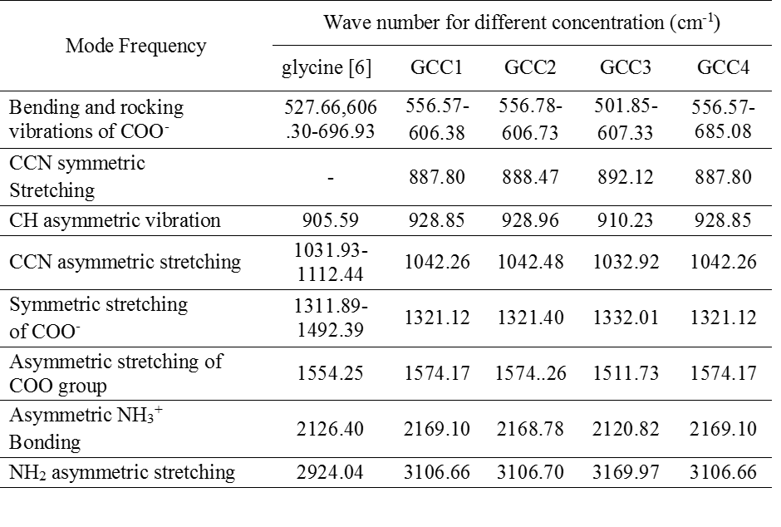

Table SI.4:Cut-off wavelength and the optical band gap for GCC crystals.

|  |  |  |  |  |  |
| --- | --- | --- | --- | --- | --- |
| Optical parameter | Pure glycine1 | GCC1 | GCC2 | GCC3 | GCC4 |
| Eg(eV) | 3.16 | 5.80 | 5.76 | 5.80 | 5.83 |
| λcut off(nm) | 333 | 216 | 222 | 224 | 214 |

Table SI.5:Melting point of GCC crystals

|  |  |  |  |  |
| --- | --- | --- | --- | --- |
| **GCC4** | **GCC3** | **GCC2** | **GCC1** | **Sample** |
| 250.91oC | 254.23oC | 248.5oC | 253.34oC | Decomposition point |

Table SI.6:EPR parameters of powder GCC1 single crystal.

|  |  |  |
| --- | --- | --- |
| ∆H(G) | Ho(G) | g-values |
| 885.61 | 2433.99 | 2.7712 |